TERRAFORM TASK – 03

- Execute the script shown in the video. Implicit behaviour of Terraform:
Create a main.tf file with multiple resources – ‘local_file’ and ‘random_pet’.
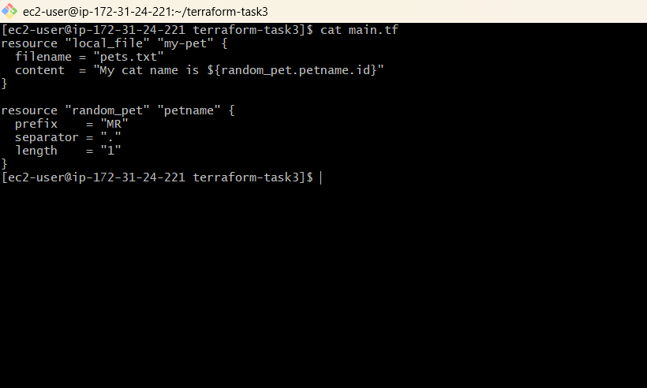
Use command : terraform init – to initiate terraform and terraform apply – to execute the terraform file.

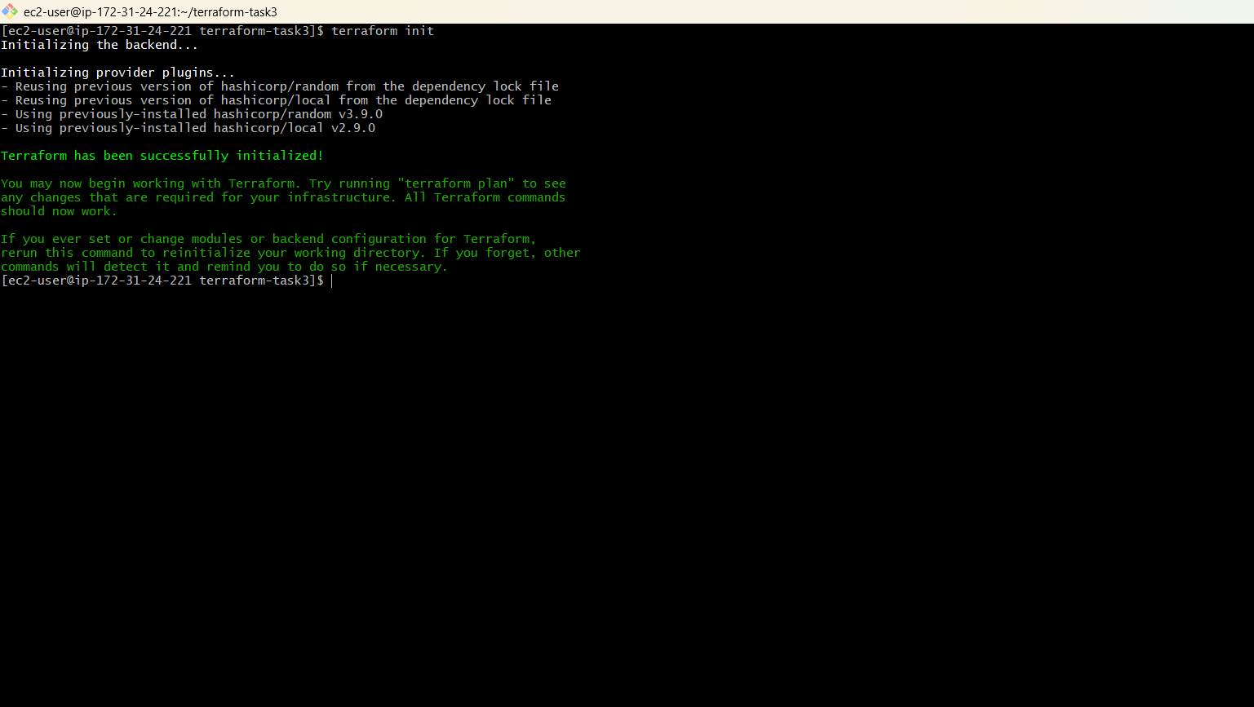
Explicit behaviour of Terraform:
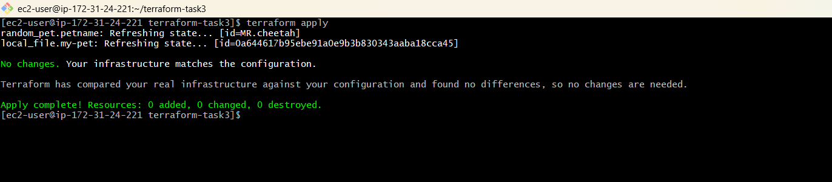

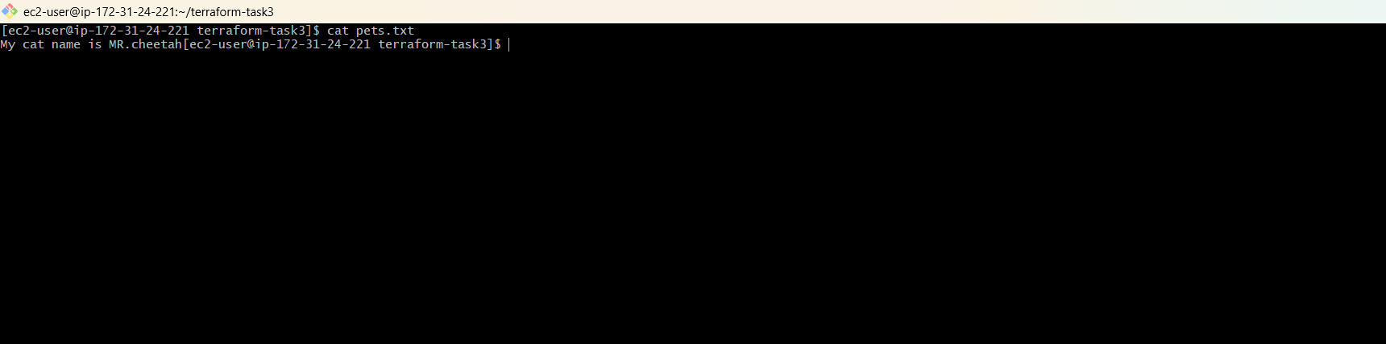

2. Integrate Terrafrom in Jenkins using the Terraform plugin.

Login to Jenkins and download the Terraform plugin :

Manage Jenkins --> Plugins --> Available plugins --> Terraform --> Download.
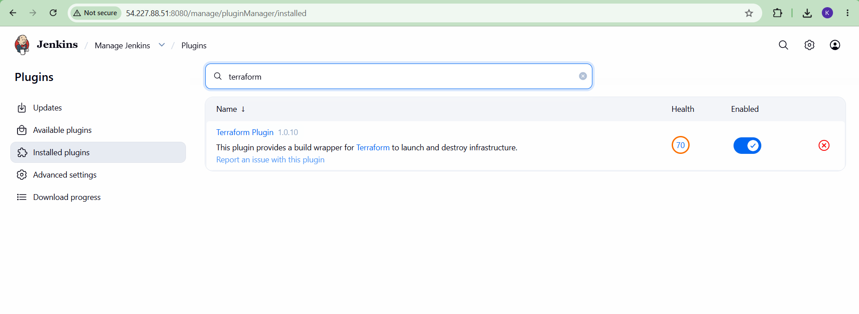
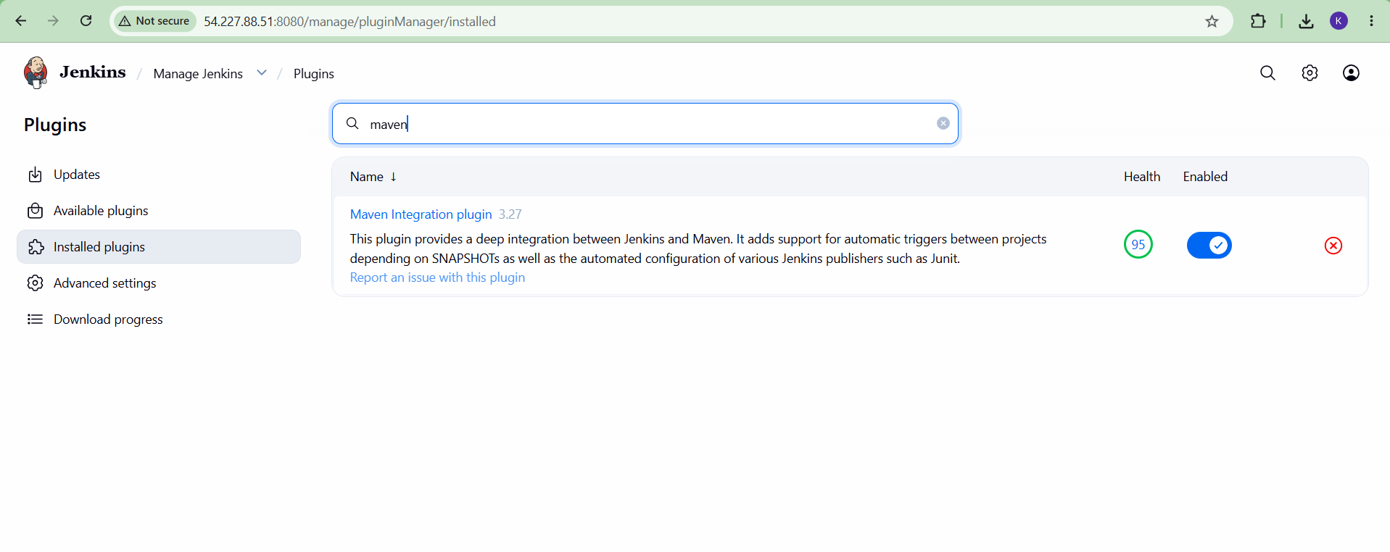
Also Download Maven Plugin which is required to run the Maven Project. Manage Jenkins --> Plugins --> Available plugins --> Terraform --> Download.

Configure Maven under -->

Manage Jenkins --> Tools --> Maven Installations --> +Add Maven --> Enter Maven name --> Enter Directory path where your Maven is stored in Jenkins server.
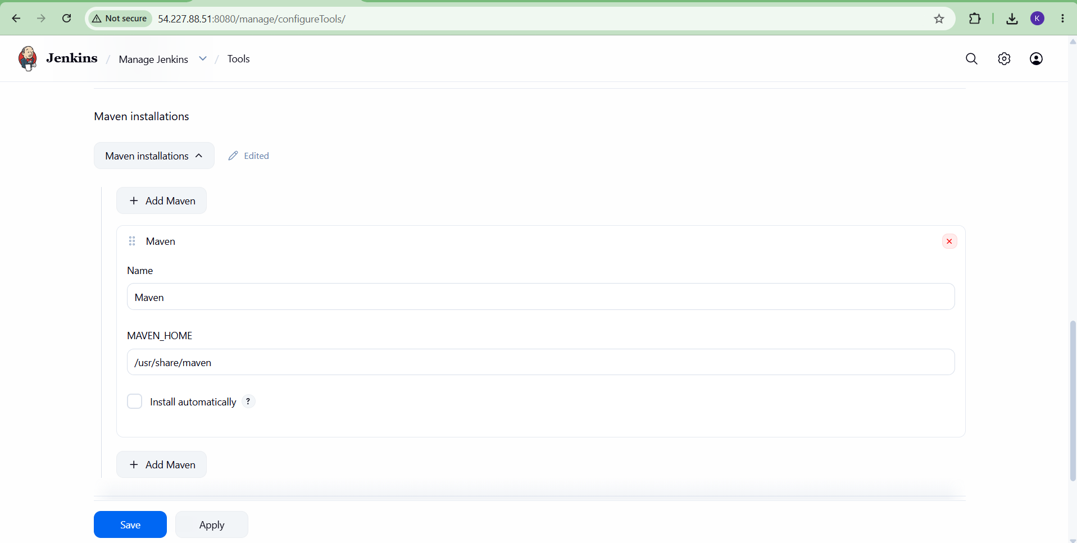

Install Terraform repo and Terraform service from using the commands

Check the version:
Terraform –version
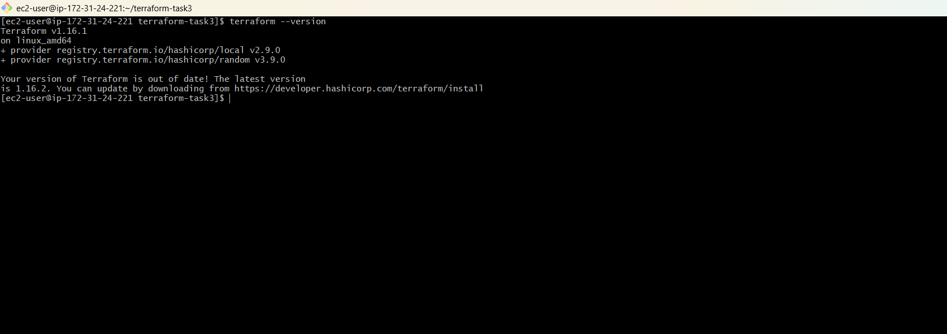
Now, integrate Terraform into Jenkins by following the process:
Manage Jenkins --> Tools --> Terraform installations --> + Add Terraform --> Provide the name
--> Path of Terraform in Jenkins server.

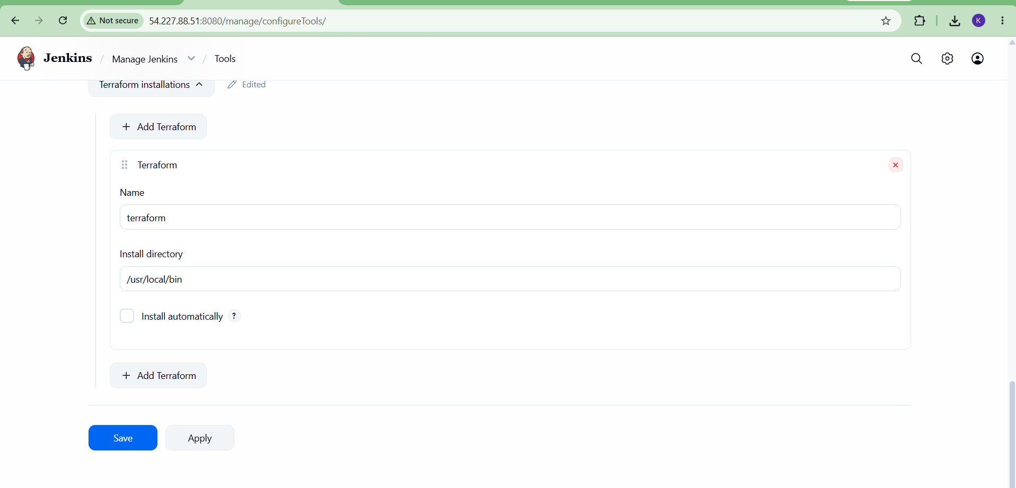

- Create one Jenkins job using Maven Project for the code below with two stages:
  - Stage 1: Git clone
  - Stage 2: Maven Compilation Code:
https://github.com/betawins/java-Working-app.git

Stage 1:
Create a new job and enter name – JAVA-WORKING-APP And Select --> Maven Project as type of job.

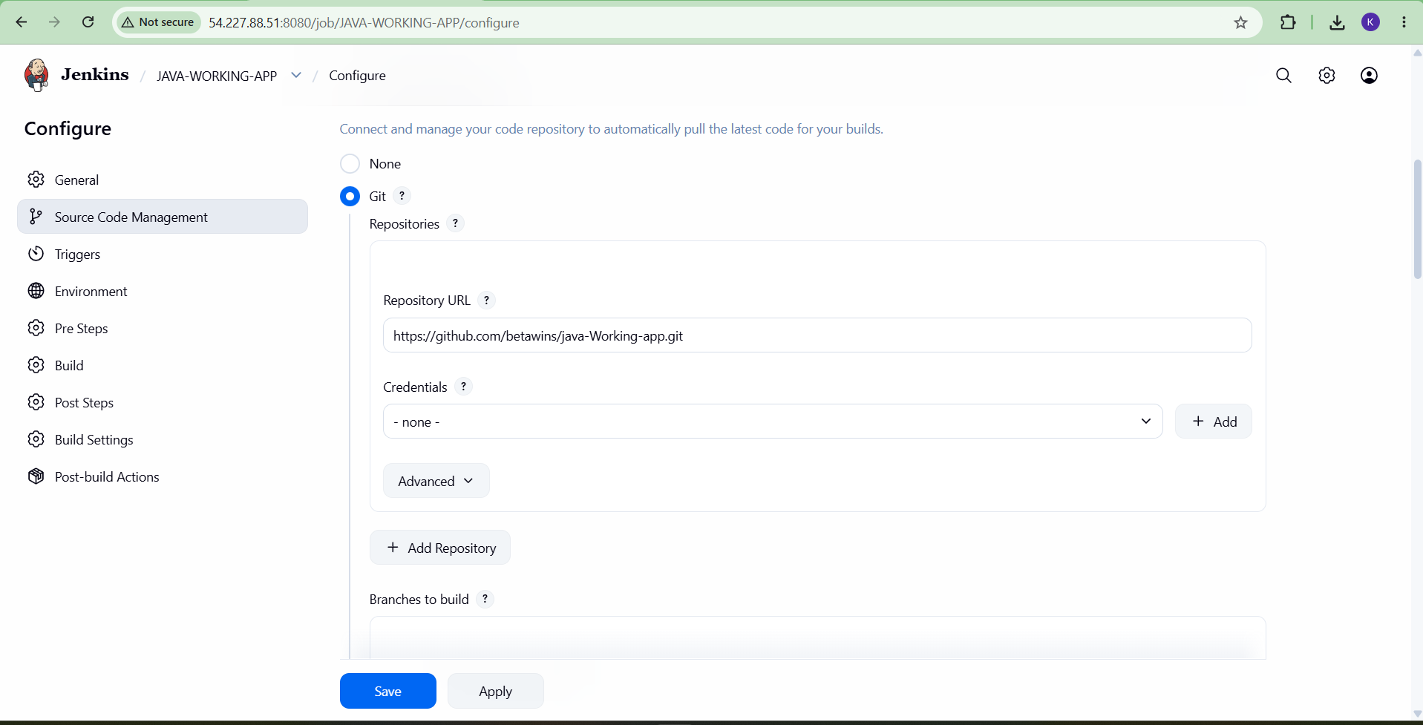Configure the job with the following steps:

Stage 2:

In Pre-Build Steps:
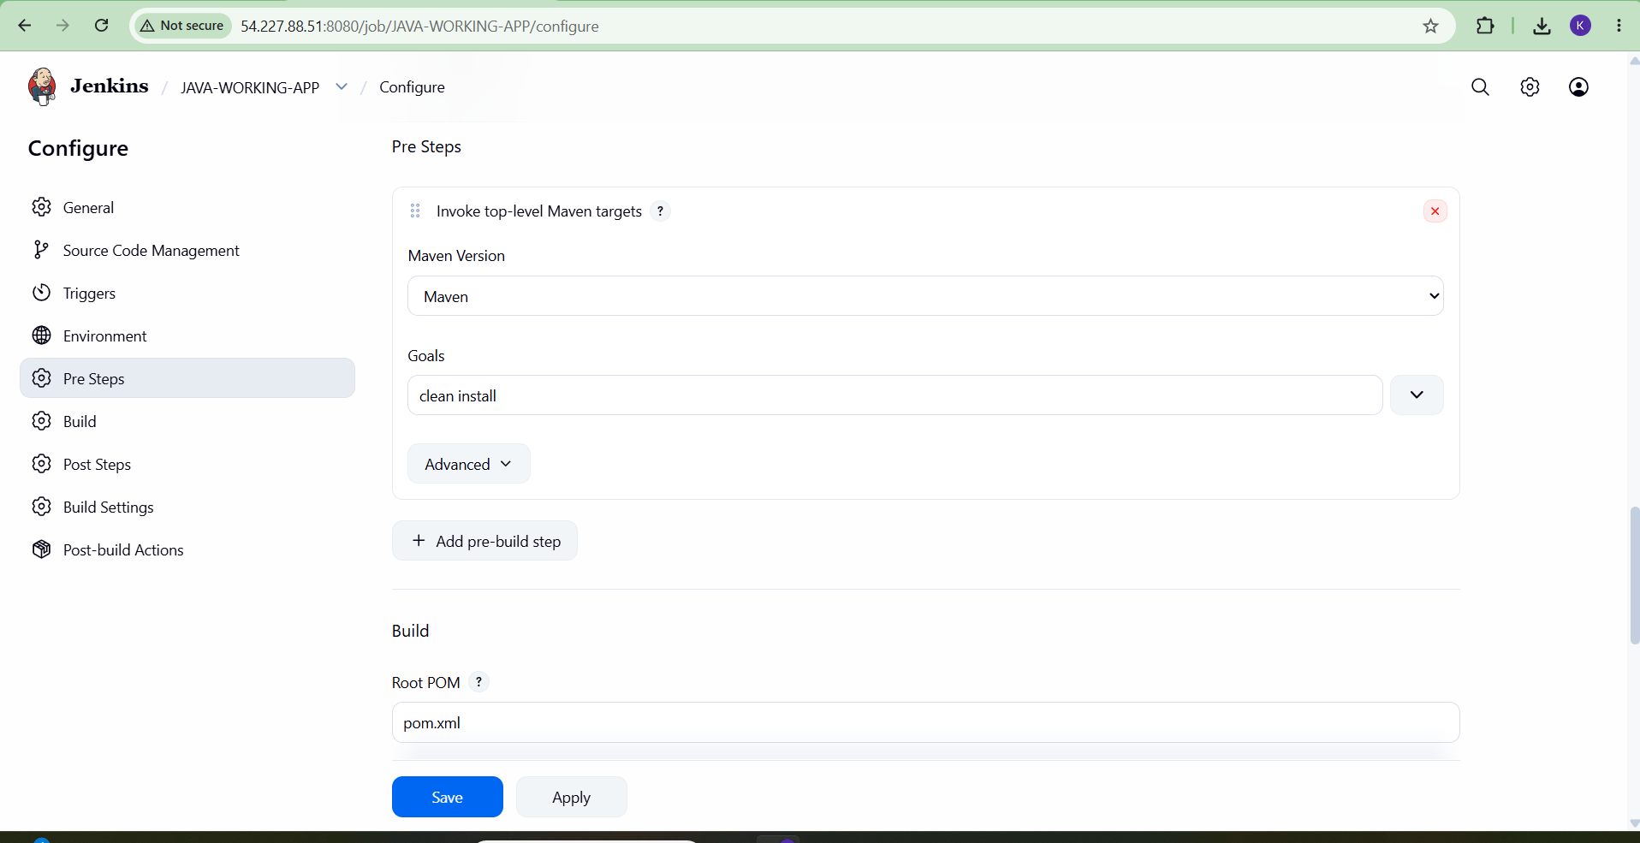Configure – Invoke top-level maven targets Select --> Maven version and Goals : clean install

Build The job

- 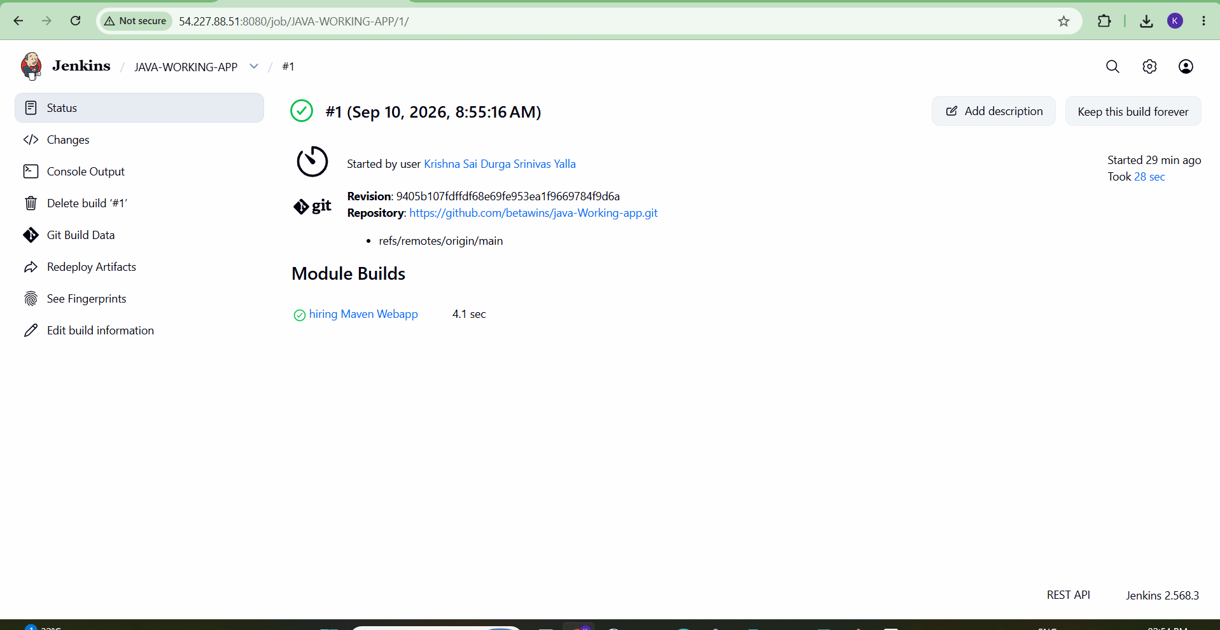Use the same code and create a parameterized job in Jenkins with:
- Stage 1:Git clone
- Stage 2:Maven CompilationCode:https://github.com/betawins/java-Working-app.git

Create a new job in Jenkins and name it JAVA-WORKING-APP-PARAMETERIZED Select type --> Maven Project

In Configurations:
General --> Select ‘This job is parameterized’ option.
Select --> Choice parameter And Provide the choices.

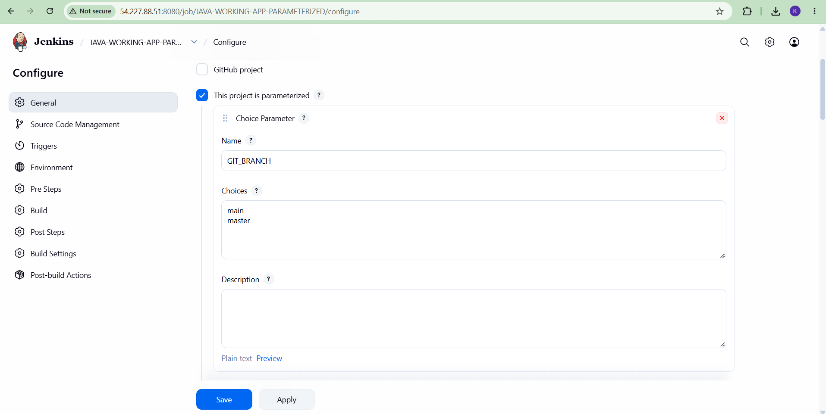

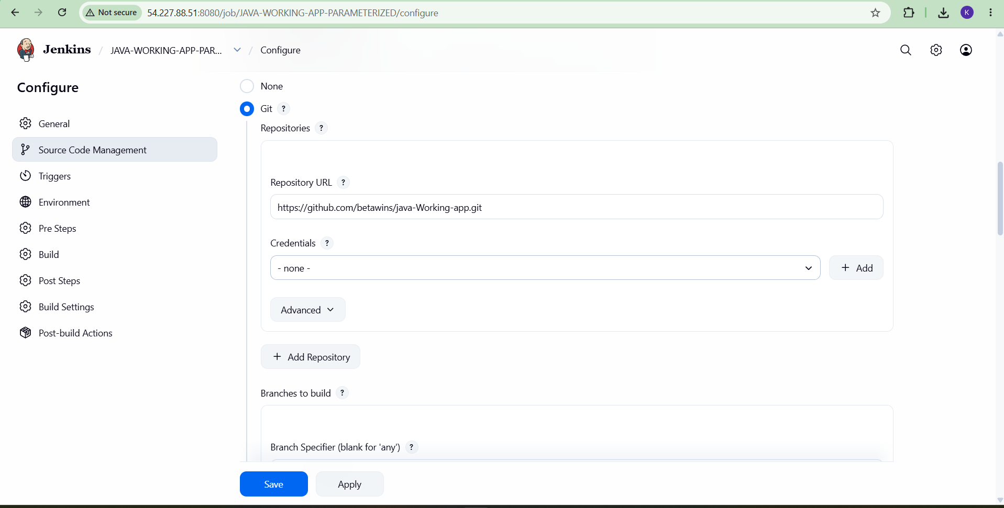Provide the source code:

In Pre-Build Steps:
Configure – Invoke top-level maven targets

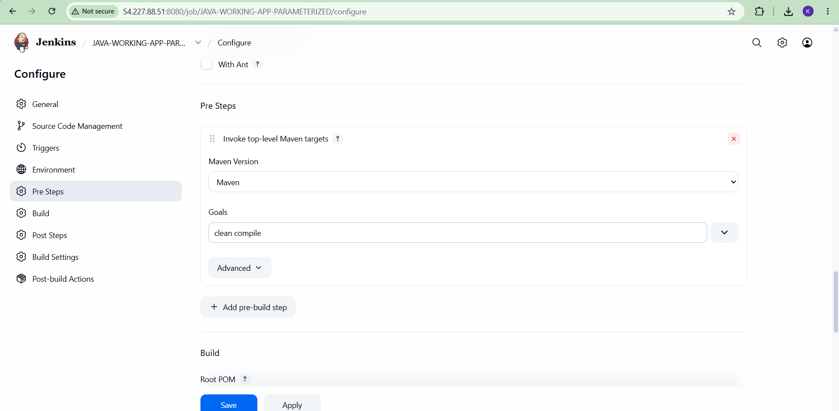Select --> Maven version and Goals : clean compile

Select Build with parameters --> When Building the job --> Select the parameter choice you want the job to be built on --> Build

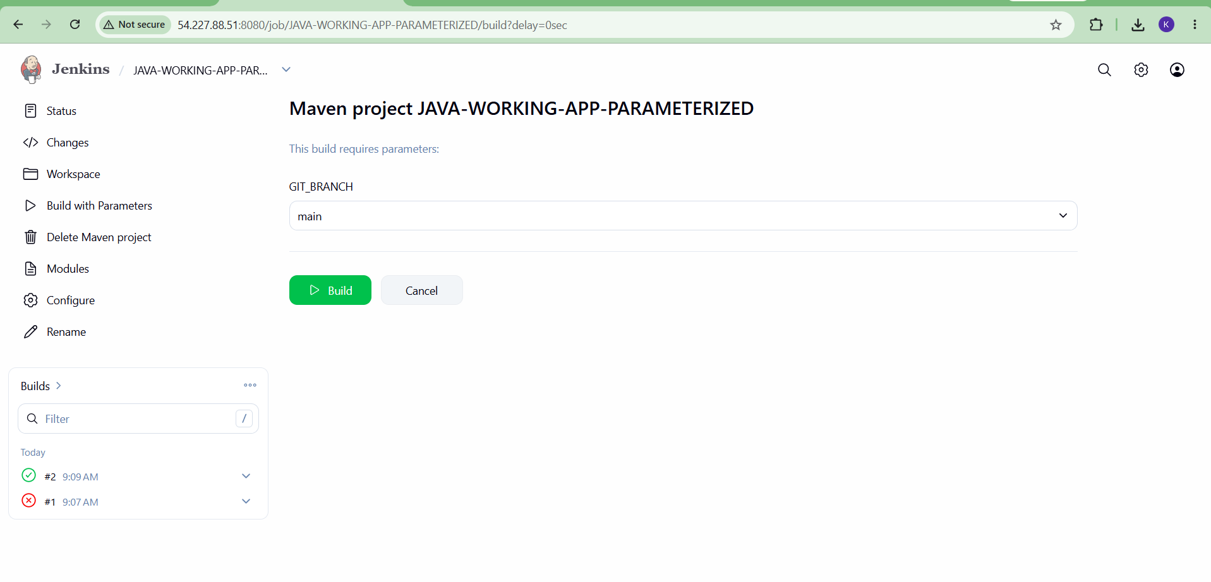
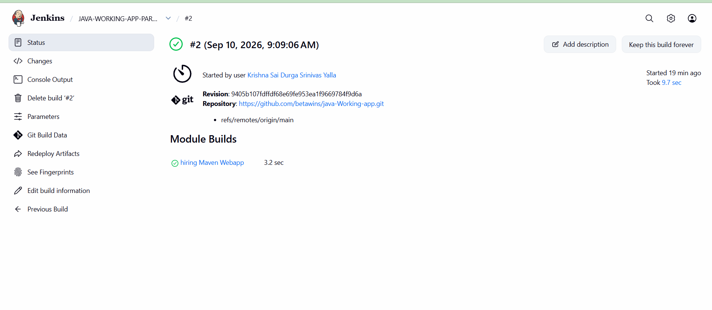
- What are the global variables in Jenkins?

In Jenkins, global variables are variables that are available throughout the Jenkins environment and can be used by multiple pipelines/jobs.
There are two common meanings of "global variables" in Jenkins:

Built-in Jenkins environment variables

Jenkins automatically provides many environment variables.

Variable | Meaning | Example
BUILD_NUMBER | Current build number | 25
BUILD_ID | Build identifier | 25
BUILD_TAG | Unique build tag | jenkins-job-25
JOB_NAME | Name of the Jenkins job | My-Pipeline
BUILD_URL | URL of the build | http://jenkins:8080/job/My-Pipeline/25/

WORKSPACE Workspace directory Agent/node running the
/var/lib/jenkins/workspace/My-Pipeline

NODE_NAME
build built-in

JENKINS_HOME Jenkins home directory /var/lib/jenkins JENKINS_URL Jenkins server URL http://jenkins:8080/ GIT_COMMIT Current Git commit a81f23...
GIT_BRANCH Current Git branch origin/main

User-defined global environment variables

You can also create your own variables that can be used by Jenkins jobs. Go to:
Manage Jenkins → System → Global properties → Environment variables

For example:

JAVA_HOME=/usr/lib/jvm/java-17 MAVEN_HOME=/usr/share/maven DOCKER_REGISTRY=docker.io

